B-5-31:

Mathlab Solution:

Program: (For small value of K while B is constant at 1)
num=[0 0 0.5];
den=[1 1 0.5];
t=0:0.1:10;
r=t;
y=lsim(num,den,r,t);
plot(t,r,'-',t,y,'o')
grid
title('Ramp response for different values of K');
xlabel('t Sec')
ylabel('Output')
text(3.2,6.5,'Unit Ramp Input')
text(6.0,3.1,'Output')

Output:

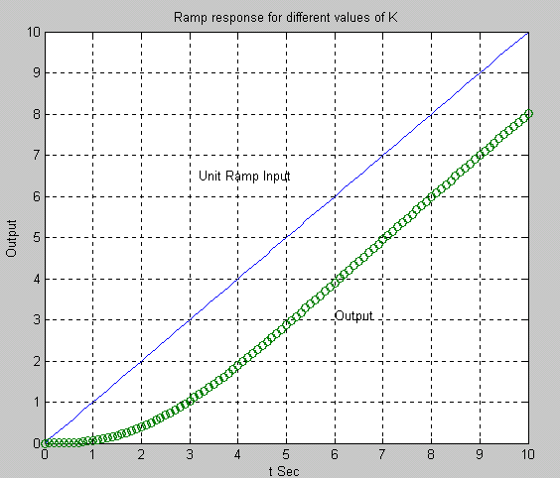

Program: (For medium value of K while B is constant at 1)
num=[0 0 8];
den=[1 1 8];
t=0:0.1:10;
r=t;
y=lsim(num,den,r,t);
plot(t,r,'-',t,y,'o')
grid
title('Ramp response for different values of K');
xlabel('t Sec')
ylabel('Output')
text(3.2,6.5,'Unit Ramp Input')
text(6.0,3.1,'Output')

Output:

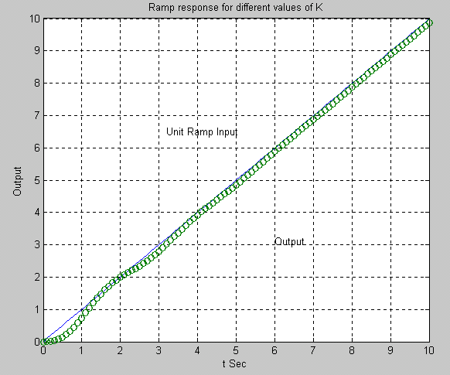

Program: (For large value of K while B is constant at 1)
num=[0 0 50];
den=[1 1 50];
t=0:0.1:10;
r=t;
y=lsim(num,den,r,t);
plot(t,r,'-',t,y,'o')
grid
title('Ramp response for different values of K');
xlabel('t Sec')
ylabel('Output')
text(3.2,6.5,'Unit Ramp Input')
text(6.0,3.1,'Output')

Output:

